Instructions: Choose FILE/PRINT. Complete the form and mail to:

Lexington Habitat

PO Box 543, Lexington, NC 27295

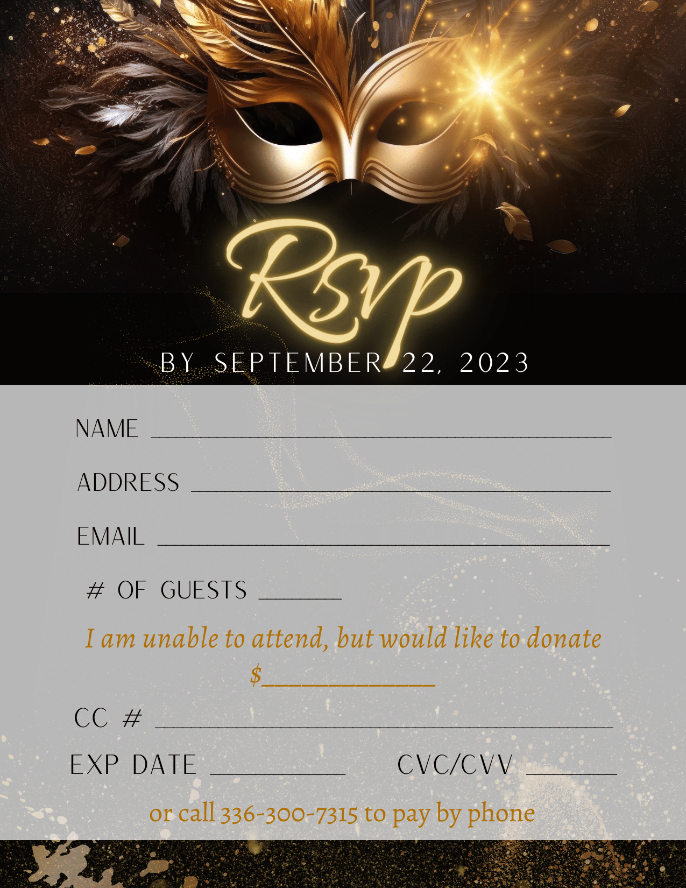**RSVP must be received by September 22nd.**